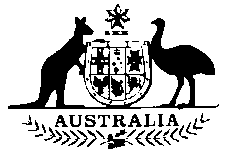
IAEA Board of Governors
2-6 March 2015

Agenda Item 6 (a): Conclusion of Comprehensive Safeguards Agreements

Thank you, Madame Chair

Australia welcomes the decision by the Government of the Federated States of Micronesia to conclude a Comprehensive Safeguards Agreement with the Agency for the application of safeguards in connection to the NPT.

We are particularly pleased to see another country from the Pacific region take this step. Australia will continue to work through the Asia-Pacific Safeguards Network to promote greater cooperation amongst safeguards authorities in our region.

